Transcranial Direct Current Stimulation (tDCS) Device

Donghyun (David) Seo, Carim-Sanni Sobur, Eric Luu, Radhanath Purakait, Shalih Miah

Midterm Report

BME 4600: Biomedical Engineering Senior Design

Sponsor: Dr. Marom Bikson

Faculty Mentor: Professor Alessandra Carriero

TA: Jack Twiddy, Evan Azoulay

**Abstract**

The goal of this project is to create an easy to use tDCS device that may also be disposable and will require minimum setup. The target audience for this device is home consumers who are suffering from depression and anxiety. The design of the device was split into three components, headgear, electrode and circuitry. The selected headgear with the best ergonomics was the cap headgear, which was later revised with a cap + strap design. Next, the selected electrode with the best current distribution was the sponge electrode. Finally, the selected circuit is able to be powered with 9V batteries, outputs a current between 2~4 mA and includes a contact safety mechanism, ramp up and down feature at the beginning and end of the stimulation.

**Need Statement:** Need to find a way to make a low cost tDCS device for a single dose (20~45 minutes). ​

**Progress report**

**Introduction**

Throughout this semester we have approached many problems and we are continuing to develop solutions in the process of executing out the design for our tDCS device. We divided our group into two subgroups, one to work on the circuit, and the other to work on the headgear which also includes the electrodes. This way we can cover more ground and effectively tackle different problems for both circuit and headgear designs. For the circuit, we had problems with our power supply system, as well as the reliability of the circuit itself. We are currently resolving problems with the ramp and the safety mechanism. For the headgear, we had problems with the contact quality of the sponge electrodes when the cap is on the head. We are currently working on putting straps at different angles of the hat to make the sponge electrode push down on the head for better head-to-electrode contact.

**Circuit**

For the first circuit design which is shown in Figure 1 the major hurdle was selecting the right power source. Application program such as NI Multisim was used to simulate circuit design to see if 9V battery would be sufficient enough to give the desire constant current of 2 mA with the head impedance of 20k ohm. Based on the result of the simulations which is shown in Figure 2 the 9V battery was insufficient to output 2 mA of constant current.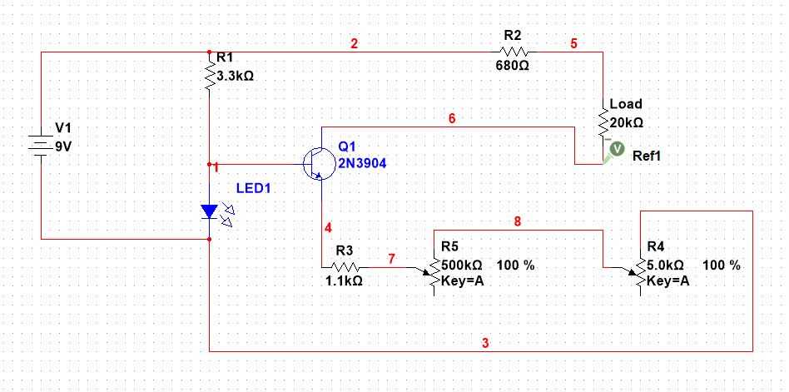

Figure 1: The first circuit design also known as BJT tDCS V1 Design 1. This circuit is powered by 9V battery and has bipolar junction transistor (BJT) to control the current.

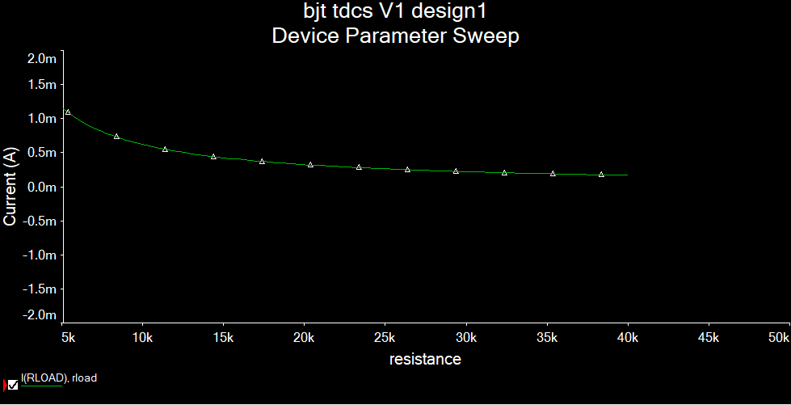

Figure 2: This graph shows the current and resistance relationship when the circuit is being powered by 9V battery. At 20k ohm the current is only 0.5 mA.

After making few changes to the first circuit the updated version of the circuit was developed and it’s shown in Figure 3. Using the updated circuit design a simulation of the relationship between voltage and current was created which is shown in Figure 4. From this, it was clear that we needed higher voltage to achieve 2mA of constant current. To solve this problem more 9V batteries was needed however, this will make the circuit bulkier in size. We found another alternative solution where we can use a boost converter to take in low input voltage and output a higher voltage.

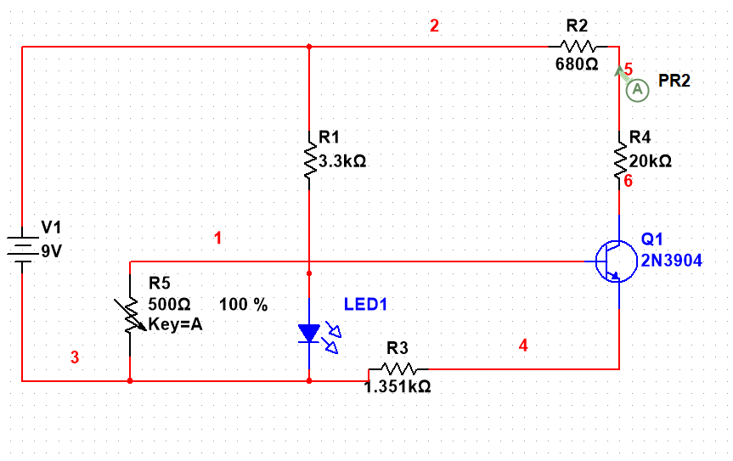

Figure 3: This is BJT tDCS V2 design 2. The resistor (R) 3,4,5 was replaced by a single resistor R3 and R5 (potentiometer) was added to the base of the BJT.

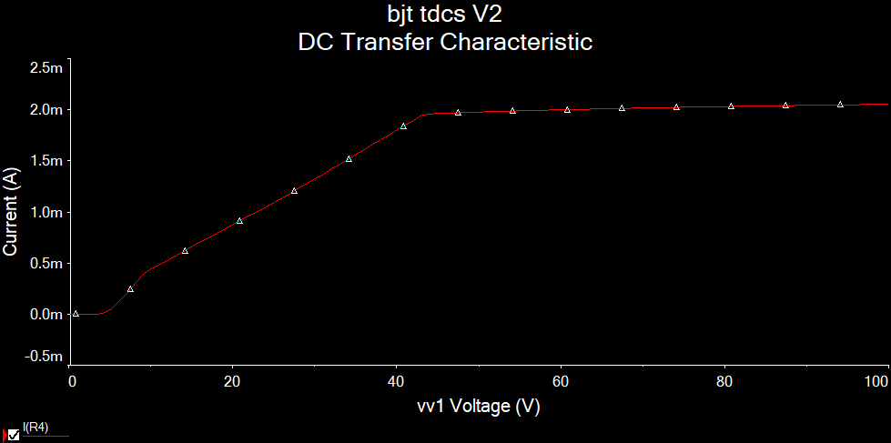

Figure 4: This graph shows the relationship between current and voltage. As the voltage increases so the current.

In order for circuit to work properly we needed a appropriate boost converter to step up the voltage from a 9V battery to the 50V which is required for the operation of our constant current circuit. We tried few different boost converter with our circuit and the first was MT3608 based boost converter which is shown in Figure 5. This boost converter had critical issues in providing both the correct voltage as well as being unreliable in general.

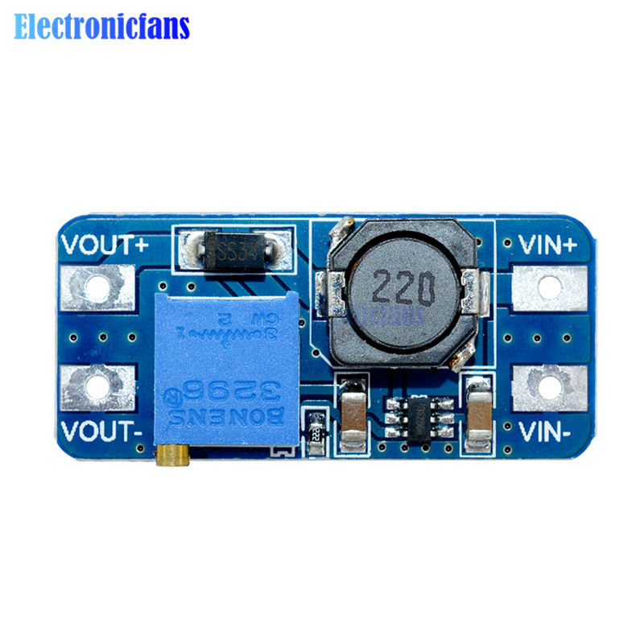

Figure 5: MT3608 boost converter [7]. This boost converter was not effective in raising the voltage. Most of the time it did not respond to the circuit and voltage output was less than 30V.

Next, we tried a design that used the XL6009E1 boost converter chip which is shown in Figure 6. When we first tried XL6009E1 it did not work but upon further testing we obtained 50V output. In another board we tried using a different XL6009E1 design which is shown in Figure 7. This XL6009E1 was cheaper and operated at a lower voltage (40V). Our final solution could use the 50V X6009E1 board, however, it is possible to design a cheaper boost converter using bare components instead of an off the shelf component. This could be part of a all in PCB which would include our constant current circuit.

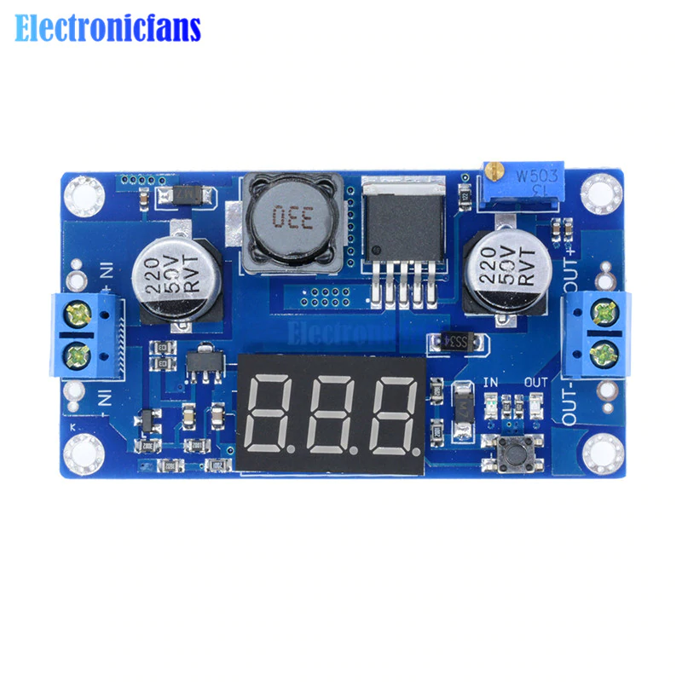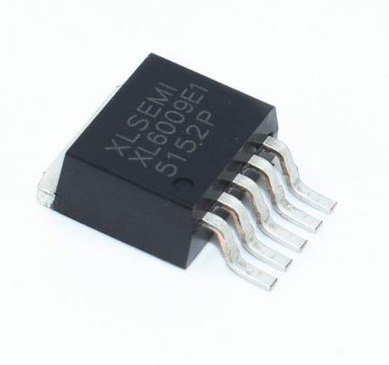

Figurer 6: XL6009E1 50V boost converter [8]. This boost converter board has XL6009E1 chip attached and can convert input of single 9V battery and output 50V. It has LED display which can show both input and output voltage.

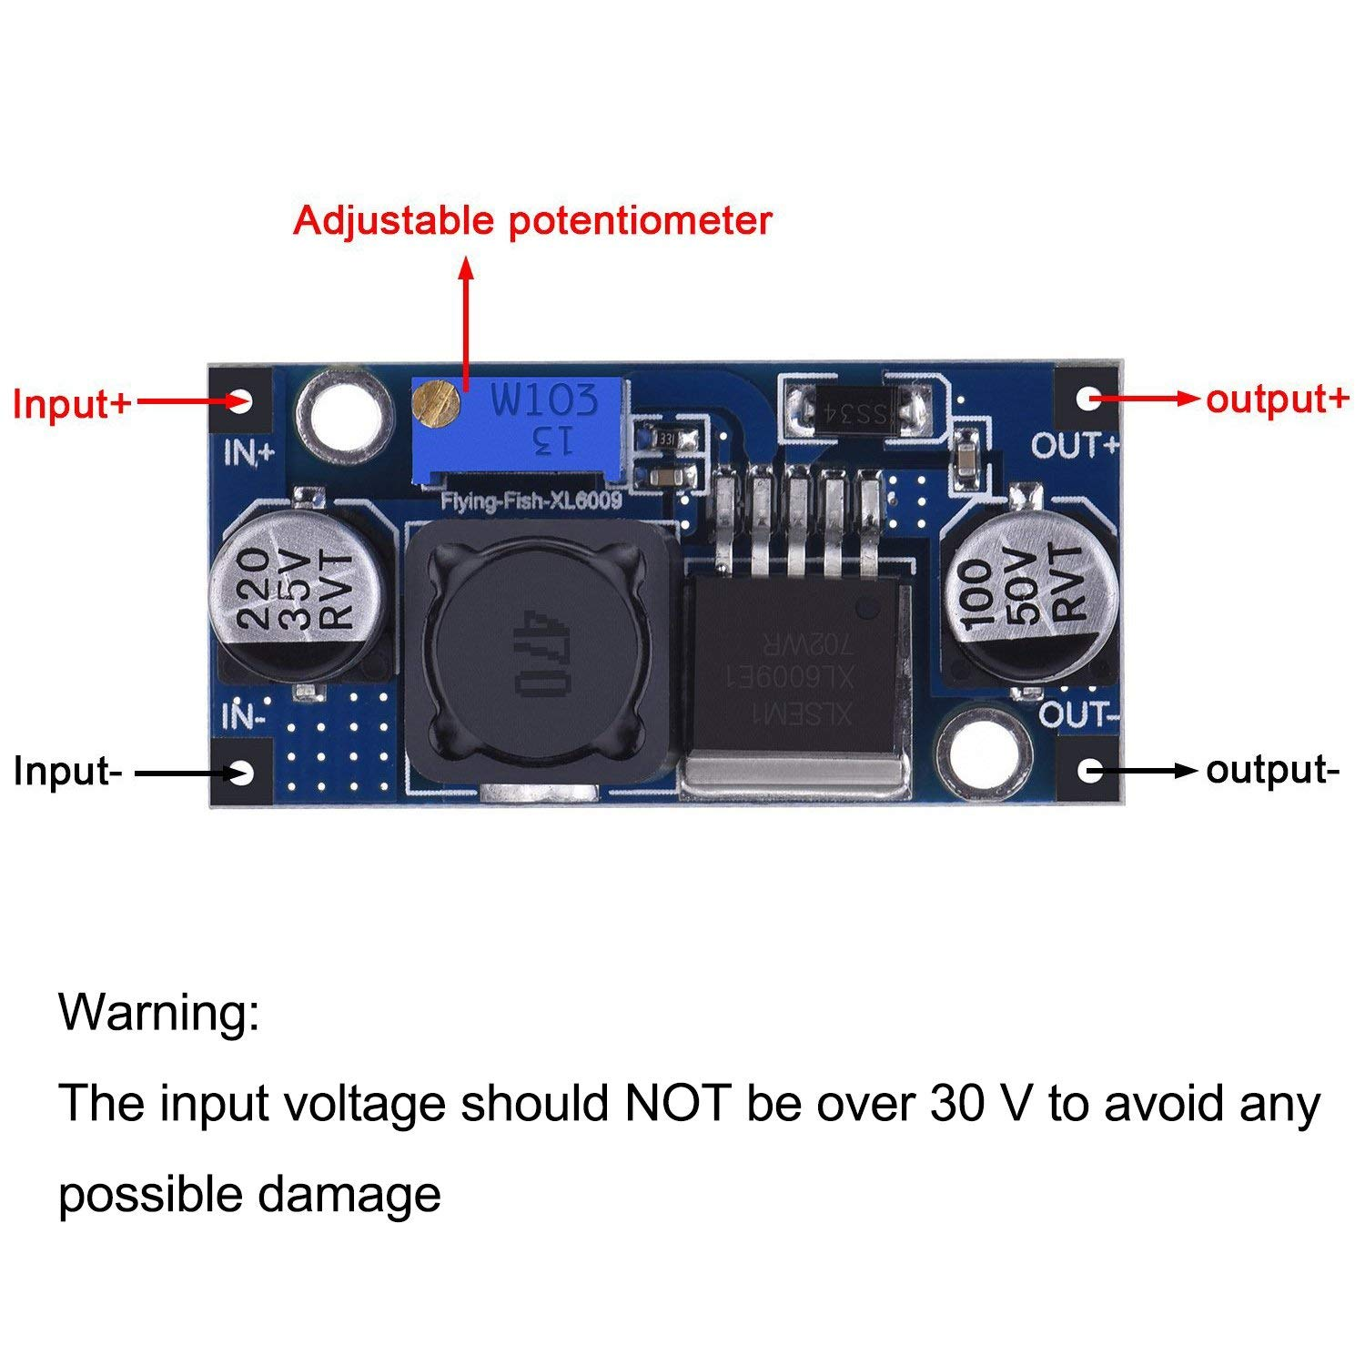

Figure 7: XL6009E1 40V boost converter [9]. This boost converter board has XL6009E1 chip attached and can convert input of two 9V batteries (18V) and output 40V.

The next circuit challenge was to increase the reliability of our circuit. This was primarily accomplished by using NI Multisim simulation methods to replace potentiometer components with a fixed resistors to provide 2mA without the option for the user to switch outputs.This is shown in Table 1 under the breadboard column. We also made progress on the actual medium our circuit was on. While in theory breadboards, protoboards and pcbs should function the same, in practice however, there is in fact a difference in terms of circuit stability and usability. Initially when we were working on just the constant current circuit, we used just a breadboard, however as we started adding more features such as the ramp microcontroller and safety mechanism we moved our circuit to protoboard which is shown in Table 1. This improves stability. Other changes we implemented ot the constant current circuit was to change some resistor values to withstand higher currents without increasing resistor rating thus making parts sourcing difficult and slightly more expensive.

|  |  |  |
| --- | --- | --- |
| Breadboard | Protoboard | PCB + ext. Micro controller |
|  |  |  |
|  |  |  |

Table 1: This table shows how our circuit changed and how it looked when the circuit was on breadboard, Protoboard , and PCB.

We designed our ramp by using the transient state in a N type MOSFET (Metal oxide field effect transistor) as a variable potentiometer which is controlled by a smoothed PWM signal shown in Figure 8. We had a challenge with low pass filtering this signal because of the high noise, ultimately we solved this by using a higher value capacitors to reduce ripple voltage.We also addressed the problem of the ramp not having enough steps in the 8 bit PWM mode. To do this we changed the clock used in the atmega328p which gave us a 16 bit PWM signal. In doing this we were able to have more than 5 steps in our ramp, however the steps are not uniform, so we need to perform linear interpolation within the arduino code or fit onto the nonlinear calibration data.

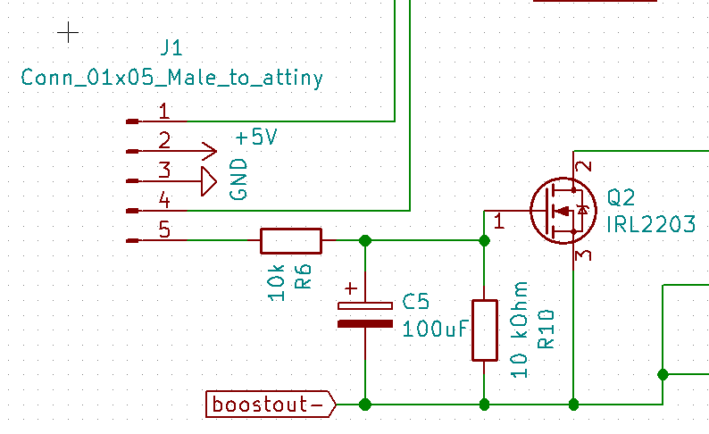

Figure 8 **:** Ramp circuit with low pass filter. Also shown: the input of the ramp circuit goes to pin 5 of a connector, which in turn goes into a pwm pin on the ATTINY, pin 1 provides a signal to the attiny for the measurement of output voltage, pin 4 toggles a MOSFET to an open or closed state when it is waiting for the user to put on the cap.

We are also working on a safety feature where the user will not be able to operate the device until the circuit detects an impedance across the output. This would prevent sudden onset of the output current even if the user turns on the hat before placing it on their head. With our current design which is shown in Figure 9, we can observe a signal between 1V and 5V which is inversely proportional to the output voltage of our tDCS. The output voltage is in turn directly related to the load resistance of the head. We can then use the microcontroller to measure this signal and have the circuit only start ramping if and only if there is infact a reasonable load in the cap. We are working on currently matching the output range of our circuit to the input range of the arduino nano’s ADC to improve the precision of this aspect of our circuit, we may also look into improving the ADC accuracy by oversampling.

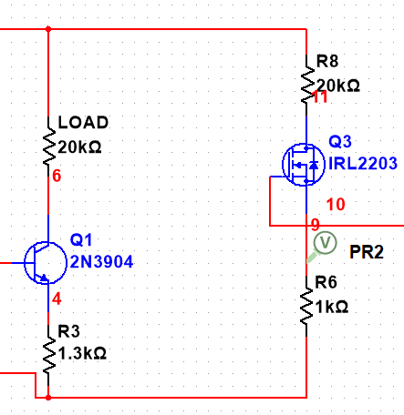

Figure 9: Headgear safety., on the right hand branch is the safety circuit, on the left is where our load is located, as the current through the left hand branch changes due to load, a corresponding and proportional change in voltage will be detected in the node labeled V.

The signals to both of the MOSFETs, as well as the signal from the mosfet will be sent to a microcontroller. Originally we started prototyping on the arduino nano. Our plan was to move on to the ATTINY85-20 microcontroller, however the microcontroller had an issue where though one of the pins were described as both input and output, it also served as a reset pin so there were technical issues that would probably not be solved within the semester. Instead we are going to go with our backup plan, to use atmega328P, the chip on the arduino nano. We already know that the arduino nano has the capability to produce the PWM signal to the mosfet “variable potentiometer, the transistor acting as a switch, buzzer signal and receive voltage feedback from the circuit. Our next decision is whether to use the raw atmega chip on a new or the arduino nano, noth options would be similar in price if a third party arduino nano is used.

In the process of developing our circuit we took advantage of modern techniques simulation and manufacturing.Though we started with a rudimentary circuit, with simulations using NI multisim we were able to rapidly test and experiment with different designs to come up with the design we have now. This allowed us to for example to Identify ways to modulate the constant current source to work over longer impedance ranges and at different current settings. We also took advantage of PCB manufacturing, thanks to our second order of components we were able to design and rush a design to pcbway, a manufacturer in china with 1 day turn around.

**Headgear**

Our headgear design was to stimulate the montage related to the depression and anxiety treatments. A sponge electrode with a snap-carbon rubber electrode (Figure 10) inserted inside is pre-assembled and snapped on the inner side of the cap. We still need to work on mounting the circuit box on the brim.

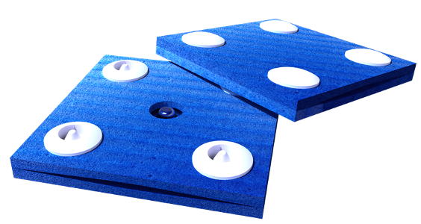

Figure 10: Sponge electrodes with a snap-carbon rubber electrode [12]

The best ergonomic of our headgear designs was the cap design (Figure 11) with the strap attached on the sides later on. Two snap pins are attached on the approximately measured montages, F3 and FP2, for depression and anxiety treatment.

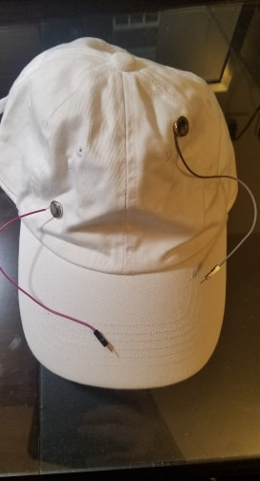

Figure 11: The cap design with two wires and two snap pins.

For the headgear one of the main problem we faced was getting a proper contact between the electrode on the F3 montage (Figure 12) and the head. The contact issue increased the head impedance measurement from the epected range of 10kΩ-20kΩ to 300kΩ. This measurement varies with different people and the involvement of the hair.

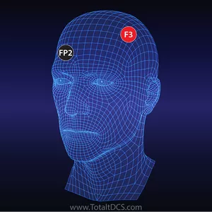

Figure 12: Montage F3 and FP2 of the head for the depression and anxiety. [11]

To ameliorate the issue, we added a three way strap configuration to put more pressure on the electrode. The first strap goes directly over the electrode to apply force over the electrode. The second strap goes behind the head above the neck to prevent the force from pushing the user’s head forwards. Lastly, the third strap connects in between the first two straps and goes under the chin to secure the hat and apply equal pressure to both the electrode and the back of the head.

We also found out that extra saline was needed to be applied to the sponge, which comes pre moistened, to maintain the low impedance for a longer period of time and to decrease the impedance on the scalp through the hair.

Furthermore, there was a problem with our snap configuration. The place where the third strap connects to the first two straps, comes in contact with the ear. To counter the problem we researched various hat designs to see if there are potential hats that had resolved an issue similar to ours. An idea came from the snow hats/ bike hats with an over the ear “V” shaped design that will not only fasten the electrode on to the head but also solve the problem with the straps coming in contact with the ear.

In the progress of adding extra saline on the sponge electrodes, we found out that the saline solution was seeping into the fabric of the headgear, which is critical in reading the actual impedance because the amount of the saline go through the scalp will be altered. Also, the two moistened areas can be connected and affect the reading of the impedance. The bigger issue with moistened fabric is when the subject is receiving the treatment, the current will also flow through the hat. The team came up with an idea of using hydrophobic spray, which can avoid saline soaking the hat, to counter the problem.

**Testing protocols:**

For Circuit:

The primary testing protocol for the circuit will be by first measuring output current with respect to the impedance of the head which will be simulated with just a resistor. We have conducted this test to both assess out outcome measure in terms of output current and range of resistances in which our device will work.here is some data we have already collected.

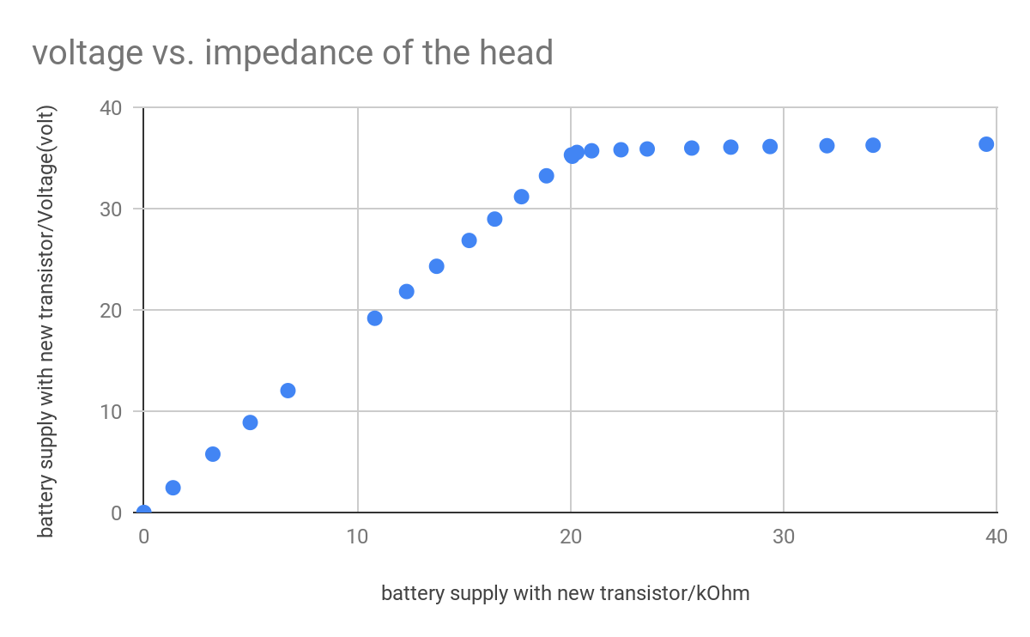

Figure 13: This graph of the circuit shows that the voltage increases up to resistance limit

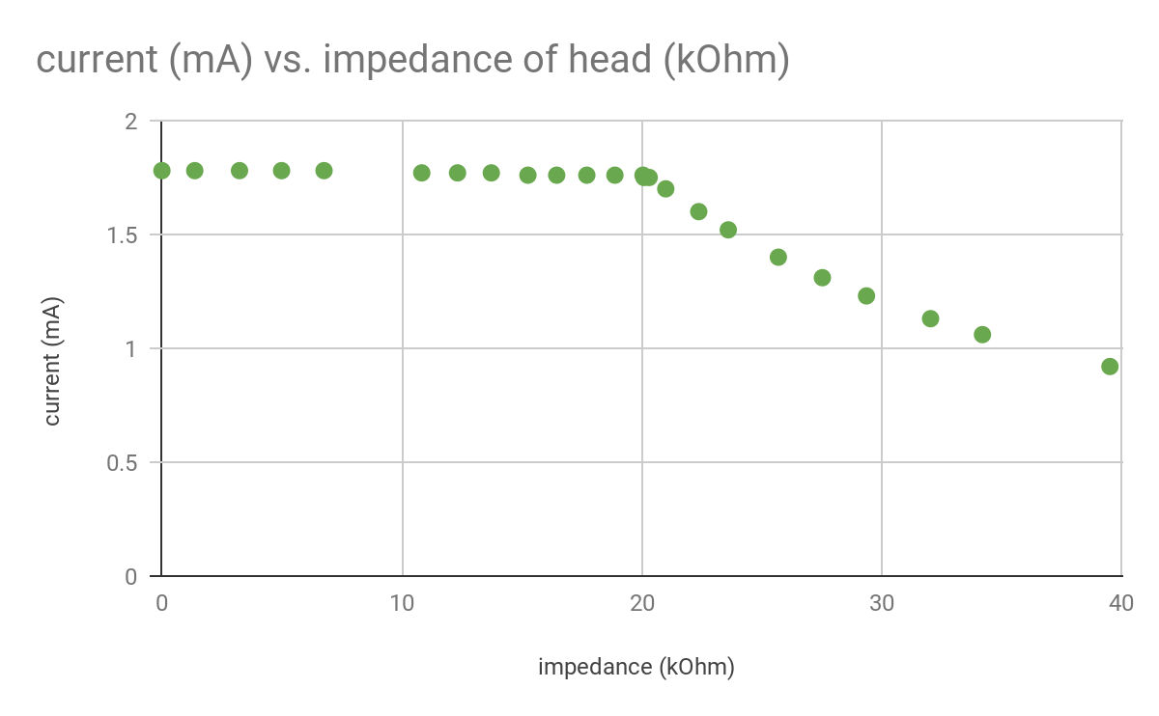

Figure 14:The current is constant until resistance limit

Another testing protocol which will be necessary will be to measure the output current of the circuit versus time as well as battery voltage. This test will help us assess whether our circuit will last for the dose duration and the necessary tolerances for the battery should transport be an issue. If we use an oscilloscope we will also be able to assess the quality of the output voltage signal as well as

Visualizing the ramp our circuit produces is something we are testing constantly to improve the quality of our output and it is essentially a test to validate the ramp parameter.

For Headgear:

The testing protocol for the headgear will be using are:

**SUS (System Usability Scale)**

The SUS test will allow us to gauge how easy it is to properly use the hat. The SUS test will have 10 questions with 5 response options numbered one to five. The test is scored by subtracting one from the user response from odd numbered items and subtracting the user response by five for even numbered items [5]. All the numbers are then added and multiplied by 2.5 convert the scale from 0 to 100. The average SUS score from 500 different studies is 68, so a value above 68 would be considered above average and a value below 68 would be considered below average [5].

To administer the SUS test we will provide the user with instructions on how to put on the hat but not interfere with the procedure. We will then measure the impedance to see if the user will be able to get an impedance, within our working range, without any assistance.

To determine the sample size that we need a research paper on specifying participant groups on usability testing, showed that a sample size of 15 is within 97.050% of the mean number of problems found as seen in Table 1 [6]. Table 1 also shows that increasing the sample size from 5 to 10 greatly increases the number of problems found. Increasing the sample size from 10 to 15 and so on, however, shows that the number of problems found minimally increases. This shows that SUS doesn’t require a large sample size to yield analytical results. Based on the research paper, we decided to choose a sample size of 15.

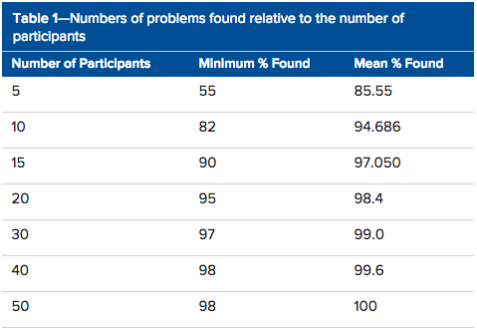

Figure 15: Shows the jump in number of problems found from 5 to 10 participants

SUS will consist of these questions:

1. I think that I would like to use this system frequently.

Strongly Disagree Strongly Agree

|  |  |  |  |  |
| --- | --- | --- | --- | --- |
|  |  |  |  |  |

1 2 3 4 5

1. I found the system unnecessarily complex.

Strongly Disagree Strongly Agree

|  |  |  |  |  |
| --- | --- | --- | --- | --- |
|  |  |  |  |  |

1 2 3 4 5

1. I thought the system was easy to use.

Strongly Disagree Strongly Agree

|  |  |  |  |  |
| --- | --- | --- | --- | --- |
|  |  |  |  |  |

1 2 3 4 5

1. I think that I would need the support of a technical person to be able to use this system.

Strongly Disagree Strongly Agree

|  |  |  |  |  |
| --- | --- | --- | --- | --- |
|  |  |  |  |  |

1 2 3 4 5

1. I found the various functions in this system were well integrated.

Strongly Disagree Strongly Agree

|  |  |  |  |  |
| --- | --- | --- | --- | --- |
|  |  |  |  |  |

1 2 3 4 5

1. I thought there was too much inconsistency in this system.

Strongly Disagree Strongly Agree

|  |  |  |  |  |
| --- | --- | --- | --- | --- |
|  |  |  |  |  |

1 2 3 4 5

1. I would imagine that most people would learn to use this system very quickly.

Strongly Disagree Strongly Agree

|  |  |  |  |  |
| --- | --- | --- | --- | --- |
|  |  |  |  |  |

1 2 3 4 5

1. I found the system very cumbersome to use.

Strongly Disagree Strongly Agree

|  |  |  |  |  |
| --- | --- | --- | --- | --- |
|  |  |  |  |  |

1 2 3 4 5

1. I felt very confident using the system.

Strongly Disagree Strongly Agree

|  |  |  |  |  |
| --- | --- | --- | --- | --- |
|  |  |  |  |  |

1 2 3 4 5

1. I needed to learn a lot of things before I could get going with this system.

Strongly Disagree Strongly Agree

|  |  |  |  |  |
| --- | --- | --- | --- | --- |
|  |  |  |  |  |

1 2 3 4 5

Another testing protocol would be to measure the impedance of the hat on a user’s head over a period of time. We will take measurements in 5 minute increments over the duration required for a tDCS treatment. This will allow us to see if the impedance would change over time. If the impedance does change then we can address the issue by figuring out the cause. A possible issue we might encounter is the sponge drying out or the hat losing pressure overtime.

**Project Design Specification**

|  |  |
| --- | --- |
| Parameter | Value |
| Electrode size | 25 cm^2 for 2 milliamp current (0.8 A/m2 current density) [1] |
| Current | 1-2 mA (effective dose for montage) |
| Voltage requirement | 20 V - 43 V [4] |
| Duration | 20 - 45 minutes [2] |
| Dosage | Single dose |
| Headgear circumference | Around 57.2 cm [3] (elastic material) |
| Weight | Less than 0.5 lb |
| Price | 20 USD |
| Ramp up/Ramp down | 1 mA for 30 seconds |

This shows the Project Design Specification for the tDCS hat device. All the specifications remain the same except the current. The range of the current was 2mA - 4mA [2], according to the research we did that was the usual safety threshold. However, we changed the current range to 1mA - 2mA because that was the range of effective dose for our depression montage. Also, if we want a higher current than 2mA we would need higher voltage requirement. As of now, we can only achieve 50V with the boost converter which limits our current range.

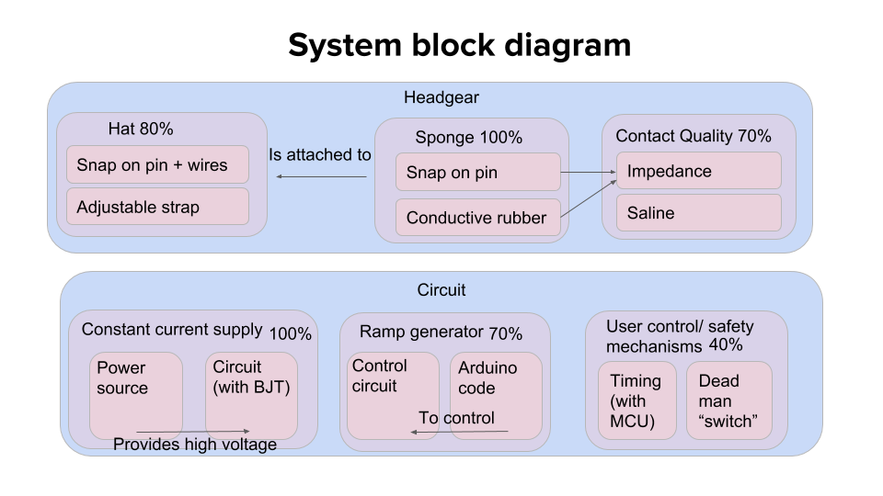

This is the system block diagram for the tDCS hat device. The device was divided into two separate block diagram Headgear and Circuit. The progress of each component is shown in top of the blocks in percentage. For the headgear block diagram, there are three components Hat, Sponge, and the Contact Quality. The hat is 80% because even though putting the snap on pins with wires to test the head impedance was successful, the adjustability and comfortability of the hat still poses an issue. To solve this, straps are being tested at different angles of the hat for better adjustability and comfortability. The contact quality is 70% because when the hat is put on the head the sponge electrode that's supposed to make contact with the scalp does not make good contact. This is due to not enough force is being applied to the sponge electrode to make a good electrode-to-scalp contact. This problem can also be solved by strap adjustability where the straps will apply force on the sponge electrode to make better contact.

For the Circuit block diagram, we achieved our goal of 2mA constant current within an impedance of 35 kohm and can go even higher if the voltage is increased higher than 50V. We generated a ramp for the circuit but more resolution and noise cancellation is required for smoother ramp. Safety mechanism was developed where the circuit would not function properly until it senses a certain head impedance. Progress on both ramp generator and safety mechanisms are still being made and more testing is being done to improve it.

**Estimated BOM**

|  |  |  |  |
| --- | --- | --- | --- |
| Item | Bulk pricing estimate | Low quantity pricing (10 units) | Quantity |
| [hat](https://www.amazon.com/dp/B07B4MLNT9/ref=sspa_dk_detail_3?pd_rd_i=B07B4LGWK7&pd_rd_w=Z7MHU&pf_rd_p=f0dedbe2-13c8-4136-a746-4398ed93cf0f&pd_rd_wg=Rmk3w&pf_rd_r=JPQN2MECWP9F2ADT5NXJ&pd_rd_r=5ea10233-27fd-11e9-bd5b-dfbc5f26256b&th=1) | [$1.5 @ 1k](https://www.alibaba.com/product-detail/Wholesale-High-Quality-Custom-6-Panel_60738470944.html?spm=a2700.7724857.normalList.170.45157c15LOrMBB) | $3.33 | 1 |
| [saline 15 mL](https://www.amazon.com/Modudose-Unit-Dose-Saline-Box/dp/B00AQLMLZK) | $0.415 | $0.415 | 1 viral (15mL) |
| [Snap fastener kit](https://www.amazon.com/KINGSO-leather-buttons-decoration-Fasteners/dp/B076J89KD1/ref=mp_s_a_1_4?ie=UTF8&qid=1549594365&sr=8-4&pi=AC_SX236_SY340_FMwebp_QL65&keywords=kingso%20snap&dpPl=1&dpID=51XY%2B4UpAFL&ref=plSrch&fbclid=IwAR3ud0DIE_mZhq7Af3VHIJ4p4TS0megDOxP0BQRjotGgvohU2435XEDXTe4) | $0.19 | $0.19 | 2 |
| [Circuit box](https://www.amazon.com/uxcell-100mmx68mmx40mm-Universal-Enclosure-Transparent/dp/B0714N28YT/ref=pd_sbs_328_4/131-8655024-4037924?_encoding=UTF8&pd_rd_i=B0714N28YT&pd_rd_r=65cf72c8-4a94-11e9-b794-47d98422d647&pd_rd_w=HlT3w&pd_rd_wg=XpKVY&pf_rd_p=588939de-d3f8-42f1-a3d8-d556eae5797d&pf_rd_r=Q7F75X4Q1B993G50ZZCV&psc=1&refRID=Q7F75X4Q1B993G50ZZCV&fbclid=IwAR3gxEc7xG2Hhy-JS7J-QkjeZXY5gptpy2YawdbwwuIZNFMMo5srUX3pozw) | TBD | $6.99 | 1 |
| [Hydrophobic spray](https://www.amazon.com/Waterproof-Upholstery-Hendlex-Hydrophobic-Nanotechnology/dp/B01M13K0O1/ref=sr_1_2_sspa?crid=1FDBT5PGUS855&keywords=hydrophobic+spray&qid=1552785867&s=gateway&sprefix=hydrophobic+%2Caps%2C145&sr=8-2-spons&psc=1#customerReviews) | $0.63 | $0.63 | 5 mL |
| [Strap](https://www.amazon.com/Bluecell-Black-Nylon-Heavy-Webbing/dp/B00KCC1H6C/ref=sr_1_6?keywords=strap&qid=1552930792&s=industrial&sr=1-6) | $0.603 | $0.603 | >1 yard |
| [Velcro](https://www.amazon.com/VELCRO-Brand-Industrial-Strength-Superior/dp/B0010HADEA/ref=sr_1_3?crid=1P1GDG6IZSPAP&keywords=velcro+strips+with+adhesive&qid=1553010527&s=gateway&sprefix=velcro%2Caps%2C161&sr=8-3) | $1.34 | $1.34 | 1 set |
| [resistors](https://www.amazon.com/REXQualis-Resistor-Assortment-Kit-Values/dp/B07D54XMFK/ref=sr_1_2_sspa?ie=UTF8&qid=1546451385&sr=8-2-spons&keywords=resistor+kit&psc=1) | $0.0154 | $0.0154 | 10 |
| [220 uF cap.](https://www.mouser.com/ProductDetail/Panasonic/EEU-FS1K221?qs=sGAEpiMZZMsh%252B1woXyUXj3Q6FWM8D%252BEZmdJPa3tw%252Bjo%3D) | $0.284 @ 25k units | $0.601 | 2 |
| [100 uF cap.](https://www.mouser.com/ProductDetail/Panasonic/EEU-FS1K101L?qs=sGAEpiMZZMsh%252B1woXyUXj3Q6FWM8D%252BEZ60GocZgBueY%3D) | $0.17 @ 25k units | $0.39 | 1 |
| [10 uF cap.](https://www.mouser.com/ProductDetail/Nichicon/UPJ1K100MED1TD?qs=sGAEpiMZZMsh%252B1woXyUXjyKa7kR1qi6N%2FCBwmGzf1UU%3D) | $0.079 @4k units | $0.231 | 1 |
| [MOSFETs (N channel)](https://www.mouser.com/ProductDetail/Infineon-Technologies/IRL2203NPBF?qs=%2Fha2pyFaduj916qBev3m3VRN03mAn%2Ffz5wjcjK7eDUAk8vB3JhbJFQ%3D%3D) | $0.655 @ 1k units | $1.22 | 2 |
| [Npn BJT (2N3904)](https://www.mouser.com/ProductDetail/Central-Semiconductor/2N3904?qs=sGAEpiMZZMutncetXCRkfoW1QkrbVyPn) | $0.075 @25k units | $0.0445 | 1 |
| [5V regulator](https://www.mouser.com/ProductDetail/Texas-Instruments/LM7805SX-NOPB?qs=sGAEpiMZZMuKfYsiLTIqmBfgvtBJBVWLvyzCrlylmP0%3D) | $0.652 @ 10k units | $0.41 | 1 |
| [Shottkey diode](https://www.digikey.com/product-detail/en/on-semiconductor/MBR360RLG/MBR360RLGOSCT-ND/822814) | $0.20954 @ 500 units | $0.49 | 1 |
| l[ed](https://www.amazon.com/Projects-B-0001-C08-Clear-Green-LEDs/dp/B00GDALHZS/ref=sr_1_1_sspa?keywords=led&qid=1553397098&s=industrial&sr=1-1-spons&psc=1) | $0.07 | $0.07 | 1 |
| [inductor](https://www.digikey.com/product-detail/en/bourns-inc/SRN6045-330M/SRN6045-330MCT-ND/2756167) | $0.29670 @500 units | $0.49 | 1 |
| [buzzer](https://www.digikey.com/product-detail/en/pui-audio-inc/AT-1224-TWT-5V-2-R/668-1470-ND/5011404) | $0.25600 @ 5k units | $0.478 | 1 |
| [attiny85-20PU](https://www.digikey.com/product-detail/en/e-switch/EG1218/EG1903-ND/101726) | $1.03000 @100 units | $1.24 | 1 |
| [Crystal oscillator](https://www.amazon.com/VAPKER-Oscillator-22-1184M-Resonators-Assortment/dp/B01F59JCFE/ref=sr_1_4?crid=2HZGI9GIP1J2T&keywords=20mhz+crystal&qid=1553010806&s=gateway&sprefix=20MHz+%2Caps%2C160&sr=8-4) | $0.11 | $0.11 | 1 |
| PCB | More research necessary | $.50 per board not rushed, and not including shipping | 1 |
| Tota Price | TBD | $19.79 |  |

This is the total bill of materials (BOM) for the tDCS hat device ( headgear plus the circuit). The table is divided into three section Bulk pricing estimate, Low quantity pricing, and Quantity. The bulk pricing estimate is the price of the components if they were bought in bulk such as in units of 4k,10k,25k, etc. As it shows in the BOM table the price of the components are much cheaper when bought in large units. If this device were to be mass produced in factory then it would cost much less than making the device by buying singular components. The bulk pricing for the circuit components is $4.84 and the bulk pricing for the headgear is still to be determined due complications with finding the correct bulk pricing for the components. Thus, the total bulk pricing for the device is also to be determined.

The low quantity pricing is our actual price for the device given $600 budget. The components were bought in units of 10 and the price for the components is shown in the BOM table. The low quantity pricing for the circuit components is $6.29 and the low quantity pricing for the headgear is $13.50. The total price of the both headgear and circuit combine is $19.79 which is 21 cent lower than what was stated in our project design specification. This price might increase or decrease as we make more progress in developing the device.

**Timeline**

|  |  |  |  |  |  |  |  |  |
| --- | --- | --- | --- | --- | --- | --- | --- | --- |
| **WBS** | **Task** | **Lead** | Prede  cessor | **Start** | **End** | Cal. Days | **%**  **Done** | **Work Days** |
| **1** | **Concept Selection and Ordering Materials** |  |  |  |  |  |  |  |
| 1.1 | Team Meeting ( every Thursday) | All Members |  | Tue 1/29/19 |  |  | 100% | 0 |
| 1.2 | test component order 1 | Carim Radhanath Shalih |  | Wed 1/30/19 | Tue 2/05/19 | 7 | 100% | 5 |
| 1.3 | test powersupplys | Carim Radhanath Shalih |  | Wed 2/06/19 | Sat 2/09/19 | 4 | 100% | 3 |
| 1.4 | meet with evan ( every Thursday at 11 am ) | All members |  | Thu 1/31/19 |  | 8 | 100% | 0 |
| **2** | **Designing and assembling prototype circuit** |  |  |  |  |  |  | 0 |
| 2.1 | meet with Jack ( every Thursday and Friday) | Carim Radhanath Shalih |  | Mon 2/04/19 |  | 12 | 100% | 0 |
| 2.2 | test design 1, the inthinkerator | Carim Radhanath Shalih |  | Wed 1/30/19 | Wed 2/20/19 | 22 | 100% | 16 |
| 2.3 | revise cc design to account for higher resistance | Carim Radhanath Shalih |  | Thu 2/21/19 | Wed 2/27/19 | 7 | 100% | 5 |
| 2.4 | design timing subsystem | Carim Radhanath Shalih |  | Mon 2/25/19 | Sun 3/10/19 | 14 | 100% | 10 |
| 2.5 | build timing subsystem | Carim Radhanath Shalih |  | Sun 3/10/19 | Wed 3/20/19 | 10 | 50% | 8 |
| 2.6 | Functional Prototype for circuit | All member |  | Wed 1/30/19 | Wed 3/20/19 | 7 | 85% | 36 |
| 2.7 | design testing methods | All member |  | Wed 3/06/19 | Fri 3/15/19 | 10 | 90% | 8 |
| 2.8 | Applying testing methods | All member |  | Tue 2/19/19 | Wed 5/01/19 | 7 | 25% | 52 |
| 2.9 | develop head detection safety mechanism | Carim Radhanath Shalih |  | Wed 2/20/19 | Fri 3/15/19 | 24 | 100% | 18 |
| **3** | **prototype Headgear** |  |  |  |  |  |  | 0 |
| 3.1 | test electrode placement | Eric and David |  | Thu 2/07/19 | Fri 2/08/19 | 2 | 100% | 2 |
| 3.2 | Snap on pin and Meeting with ME prof (attach pins on test hat) | Radhanath, Eric and David |  | Wed 2/06/19 | Wed 2/06/19 | 1 | 100% | 1 |
| 3.3 | electrode positioning and headgear adjustment | Eric and David |  | Thu 2/07/19 | Mon 2/11/19 | 5 | 100% | 3 |
| 3.4 | test different caps | Eric and David |  | Thu 2/14/19 | Wed 2/27/19 | 14 | 100% | 10 |
| 3.5 | prototype 1 | Eric and David |  | Sun 2/10/19 | Sat 2/16/19 | 7 | 100% | 5 |
| 3.6 | prototype 2 | Eric and David |  | Sun 2/17/19 | Sat 2/23/19 | 7 | 60% | 5 |
| 3.7 | testing cap impedance | Eric and David |  | Tue 2/26/19 | Thu 2/28/19 | 3 | 100% | 3 |
| 3.8 | methods to lower cap impedance | Eric and David |  | Fri 3/01/19 | Thu 3/07/19 | 7 | 100% | 5 |
| 3.9 | improve electrode contact | Eric and David |  | Fri 3/08/19 | Thu 3/14/19 | 7 | 75% | 5 |
| 3.10 | ease of use testing | Eric and David |  | Fri 3/15/19 | Thu 3/21/19 | 7 | 40% | 5 |
| 3.11 | strap testing | Eric, David and Carim |  | Tues 3/12/19 | Fri 3/22/19 | 11 | 75% |  |
| 3.12 | impedance test with hydrophobic spray | Eric and David |  | Tues 3/26/19 | Tues 3/26/19 | 1 | 0% |  |
| 3.13 | testing higher concentration of saline | Eric and David |  | Thu 3/28/19 | Tues 4/2/19 | 6 | 0% |  |
| 3.14 | test concentration montage | Eric and David |  | Thu 4/4/19 | Tues 4/9/19 | 6 | 0% |  |
| 3.14a | strap and headgear design of concentration montage |  |  |  |  |  |  |  |
| **1** | **manufacture circuit** |  |  |  |  |  |  | 0 |
| 1.1 | design PCB | Carim Radhanath Shalih |  | Mon 3/11/19 | Wed 3/20/19 | 3 | 90% | 8 |
| 1.2 | order PCB (assuming JLC PCB) | manufacturer |  | Thu 3/14/19 | Wed 3/20/19 | 7 | 50% | 5 |
| 1.3 | build + design box | Eric and David |  | Fri 3/15/19 | Mon 3/18/19 | 4 | 0% | 2 |
| 1.4 | Team Report/ Presentation | All Member |  | Tue 3/19/19 | Sun 5/05/19 |  | 0% | 34 |
| **2** | **integrate design of headear and circuit** |  |  |  |  |  | 0% | 0 |
| 2.1 | Mechanical design of circuit possitioning | All Members |  | Sat 3/30/19 | Tue 4/02/19 | 4 | 0% | 2 |
| 2.2 | Wire positioning | All Members |  | Tue 4/02/19 | Fri 4/05/19 | 4 | 0% | 4 |
| 2.3 | Electrode ergonomics | All Members |  | Sat 4/06/19 | Sun 4/07/19 | 2 | 0% | 0 |
| 2.4 | User Experience Testing | All Members |  | Mon 4/08/19 | Sun 4/28/19 | 21 | 0% | 15 |
| **3** | **Final Report and Presentation** |  |  |  |  | 1 |  | 0 |
| 3.1 | Prepare for BME day (presentation) | All Members |  | 04/30/19 | Mon 5/06/19 | 7 | 0% | 5 |
| 3.2 | Prepare for BME day | All Members |  | 05/07/19 | Fri 5/10/19 | 4 | 0% | 4 |
| 3.3 | Prepare Presentation | All Members |  | Tue 5/07/19 | Mon 5/13/19 | 7 | 0% | 5 |
| 3.4 | Write Report | All Members |  | Sat 5/11/19 | Mon 5/13/19 | 3 | 0% | 1 |

We planned our project from beginning of this semester to the final presentation. The percentage shows the progress of the tasks for given time period. 100% means the task was completed and anything less than 100% is still in progress. Majority of the tasks were in time, but we found out some of them were not working so well with our plan; poor circuit parts from manufacturers and the contact quality from the headgear, delays with components, etc. Thus, we added some more sections to solve the problems and fixed the timeline.

**References**

1. Brunoni AR, Nitsche MA, Bolognini N, et al. Clinical research with transcranial direct current stimulation (tDCS): challenges and future directions. *Brain Stimul*. 2011;5(3):175-195.
2. Thair H, Holloway AL, Newport R and Smith doi: 10.3389/fnins.2017.00641
3. Neyzi O, Bundak R, Gökçay G, et al. *nical Research in Pediatric Endocrinology*. 2015;7(4):280-293. doi:10.4274/jcrpe.2183.
4. DIY | DIY Tdcs | Page 2." Diytdcs.com. N. p., 2015. Web. 15 Oct. 2018.
5. “Measuring Usability with the System Usability Scale (SUS).” MeasuringU, measuringu.com/sus/.
6. “How to Determine the Right Number of Participants for Usability Studies.” UXmatters, www.uxmatters.com/mt/archives/2016/01/how-to-determine-the-right-number-of-participants-for-usability-studies.php.
7. <https://www.aliexpress.com/item/5pcs-MT3608-DC-DC-Step-Up-Power-Apply-Module-Booster-Power-Module-MAX-output-28V-2A/32517710689.html?spm=a2g0s.9042311.0.0.9fdf4c4dpYDM26>
8. <https://www.aliexpress.com/item/DC-DC-4-5-32V-to-5V-52V-XL6009-Boost-Step-up-Module-Power-Supply-LED/2036624928.html?spm=a2g0s.9042311.0.0.9fdf4c4dpYDM26>
9. <https://www.amazon.com/eBoot-Converter-Voltage-Adjustable-Step-up/dp/B06XWSV89D/ref=sr_1_1?keywords=xl6009E1&qid=1552787011&s=gateway&sr=8-1>
10. [**https://www.amazon.com/KIMME-XL6009E1-XL6009-Step-up-263-5L/dp/B07MLSJLXH/ref=sr_1_2?keywords=xl6009e1&qid=1552787078&s=industrial&sr=1-2**](https://www.amazon.com/KIMME-XL6009E1-XL6009-Step-up-263-5L/dp/B07MLSJLXH/ref=sr_1_2?keywords=xl6009e1&qid=1552787078&s=industrial&sr=1-2)
11. “TDCS Electrode Placement Montage Guide - Total TDCS.” *Total TDCS Electrode Placement Montage Guide*, totaltdcs.com.
12. <https://soterixmedical.com/research/1x1/accessories/snappad>